Igor Oleshko
CSC 134
04/19/2022
Professor Sabzevary

Inner Join

- Display the Cartesian product of the party and candidate table

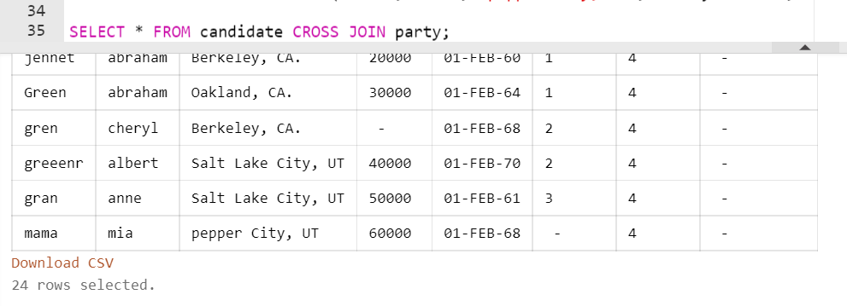

- Display the lastname and the party description of each individual

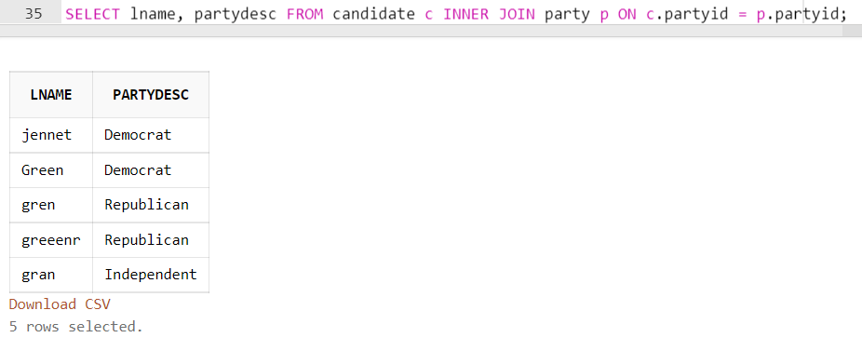

- Display the last name and the party dscription of each individual. If there is not a party description, then display no description. (Use the NVL function)

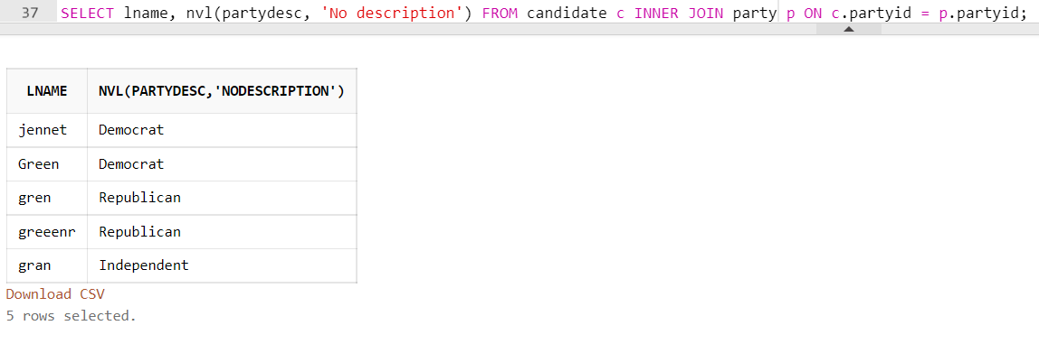

- Display the number of people in each party (display party_description)

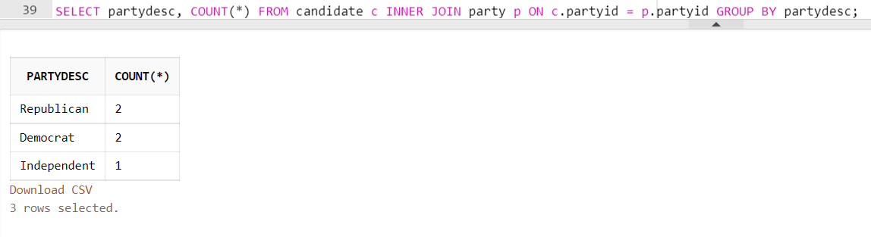

- Display the number of people in each party for only those parties whose average salary is greater than 50,000. (Identify the party name)

